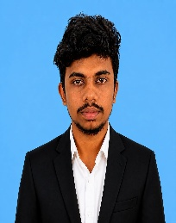
MEIYAZHAGAN R RESUME
2/157,
Aerikarai,
Kosavapalayam,
Ramapuram(po),
Tiruchengode,
Namakkal(dt)-637202.
srvishnu737@gmail.com
Mobile no:7373465873

OBJECTIVE:
To begin my career in a professional environment where I can apply my technical skills, gain valuable experience, and contribute to the growth of the organization.

ACADEMIC PROFILE:
Academic | School & College | Board & University | Percentage | Year of passing
DIPLOMA | K.S.R Institute of  Technology,  Tiruchengode. | Dote  (Chennai) | 85% | 2027
SSLC | Govt HR Sec School,ramapuram,  Tiruchengode,Namakkal | State Board  (Tamil Nadu) | 44.6% | 2022

TECHNICAL SKILLS:
- Java
- Python
- Ms word
- Html
- SQL

AREA OF INTEREST
- Artificial Intelligence
- Software Development
- Web Development
- Database Management
- Generative AI

ACADEMIC PROJECT:
AI BASED PLANT DECISE DETERGENT SYSTEM ,CURRENTLY DEVELOPING THIS PROJECT AS PART OF MY DIPLOMA ACADEMIC CURRICULUM.

TECHNICAL ACTIVITIES:
- Participated in Technical Symposiums.
- Attended Technical Workshops.
- Participated in College Technical Activities.

LANGUAGES KNOWN:
- Tamil
- English

PERSONAL PROFILE:
Name : Meiyazhagan R
Father’s Name : Rathinam
Date of Birth : 10/12/2006
Languages Known : Tamil &English (Read, Write)

DECLARATION:
I hereby declare that all the information mentioned above is true and accurate to the best of my knowledge and belief.

